DESIGN & ARCHITECTURE DOCUMENT
Car Rental System
(Task 1 – Learning Outcome 1)

1. Introduction
The purpose of this project is to design and implement a Car Rental System that automates the rental process for a car rental company. The system replaces manual paperwork with a structured, database-driven application that improves efficiency, reduces errors, and enhances customer experience.
The system is developed using Object-Oriented Programming (OOP) principles and follows a modular architectural design. Core software engineering concepts such as encapsulation, inheritance, separation of concerns, and design patterns are applied to ensure maintainability, scalability, and clarity.
The application supports two main user roles:
- Customers, who can browse cars and create bookings
- Administrators, who manage cars, customers, and rental approvals

2. Architectural Overview
The Car Rental System follows a layered architecture, where responsibilities are clearly separated into distinct layers:

2.1 Presentation Layer
- Implemented using a command-line interface (CLI)
- Handles user input and output
- Delegates all business logic to service classes
- Ensures no direct database access from the UI

2.2 Service Layer (Business Logic)
- Contains core system logic
- Includes:
  - BookingService
  - CarService
  - AdminService
- Responsible for:
  - Validation rules
  - Booking workflows
  - Approval and rejection logic
  - Notification handling

2.3 Data Access Layer
- Uses SQLite as the database
- Centralized access via the Database class
- Prevents duplicate database connections using the Singleton pattern
This architectural style improves:
- Code maintainability
- Testability
- Separation of responsibilities
- Long-term extensibility

3. Design Patterns Used

3.1 Singleton Pattern
The Singleton pattern is implemented in the Database class to ensure:
- Only one database connection exists
- Resource usage is optimized
- Consistent access to persistent data
This prevents common issues such as connection duplication and database locking.

3.2 Service Layer Pattern
Business logic is encapsulated inside service classes rather than being mixed with UI code.
This approach:
- Improves readability
- Makes debugging easier
- Supports future migration to GUI or web interfaces

3.3 Observer-like Notification Handling
Although not implemented using a formal Observer interface, the system simulates observer behavior by:
- Tracking booking status changes
- Triggering notifications for customers when bookings are approved or rejected

4. UML Diagrams

4.1 Use Case Diagram

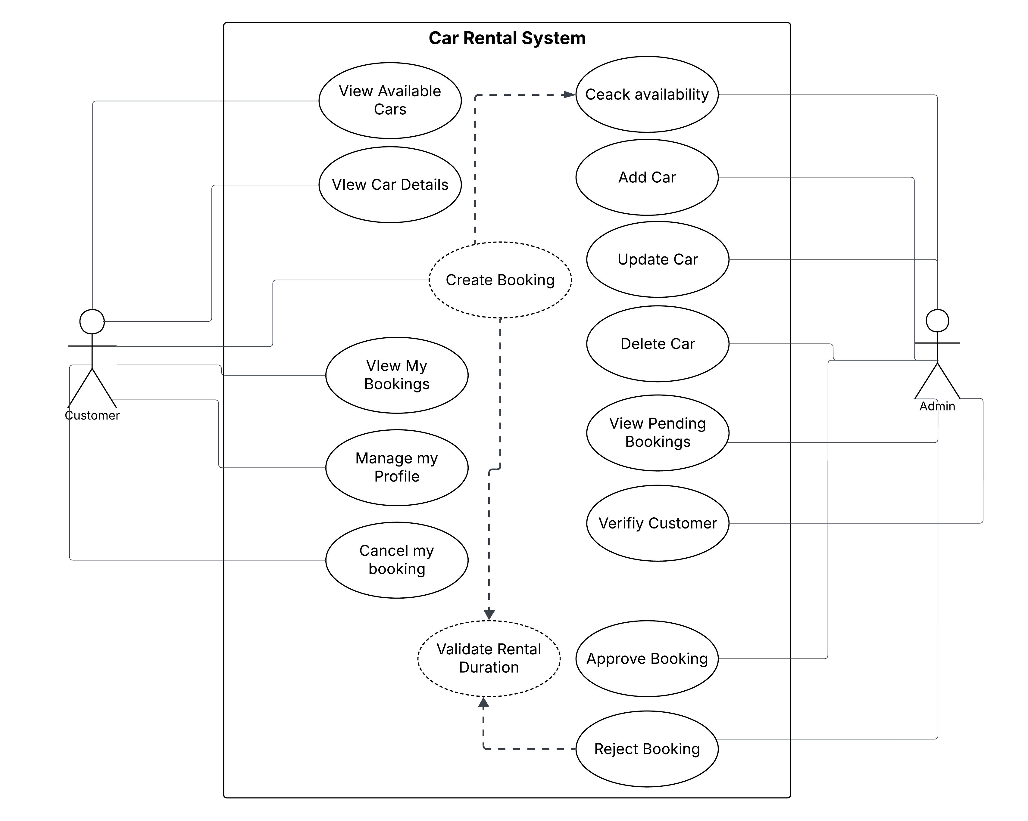

Figure 1: Use Case Diagram of the Car Rental System
The Use Case Diagram illustrates system functionality from the user’s perspective.

Actors:
- Customer
- Admin

Customer Use Cases:
- Register and login
- View available cars
- Create booking
- View booking history
- Cancel pending bookings

Admin Use Cases:
- Add, update, and delete cars
- View pending bookings
- Approve or reject bookings
- View customers
- Verify customer profiles
This diagram illustrates the interactions between system actors (Customer and Admin) and the system’s core functionalities. It clearly defines role-based access, ensuring customers and administrators interact only with authorized features.

4.2 Class Diagram
The Class Diagram represents the static structure of the system and the relationships between classes.
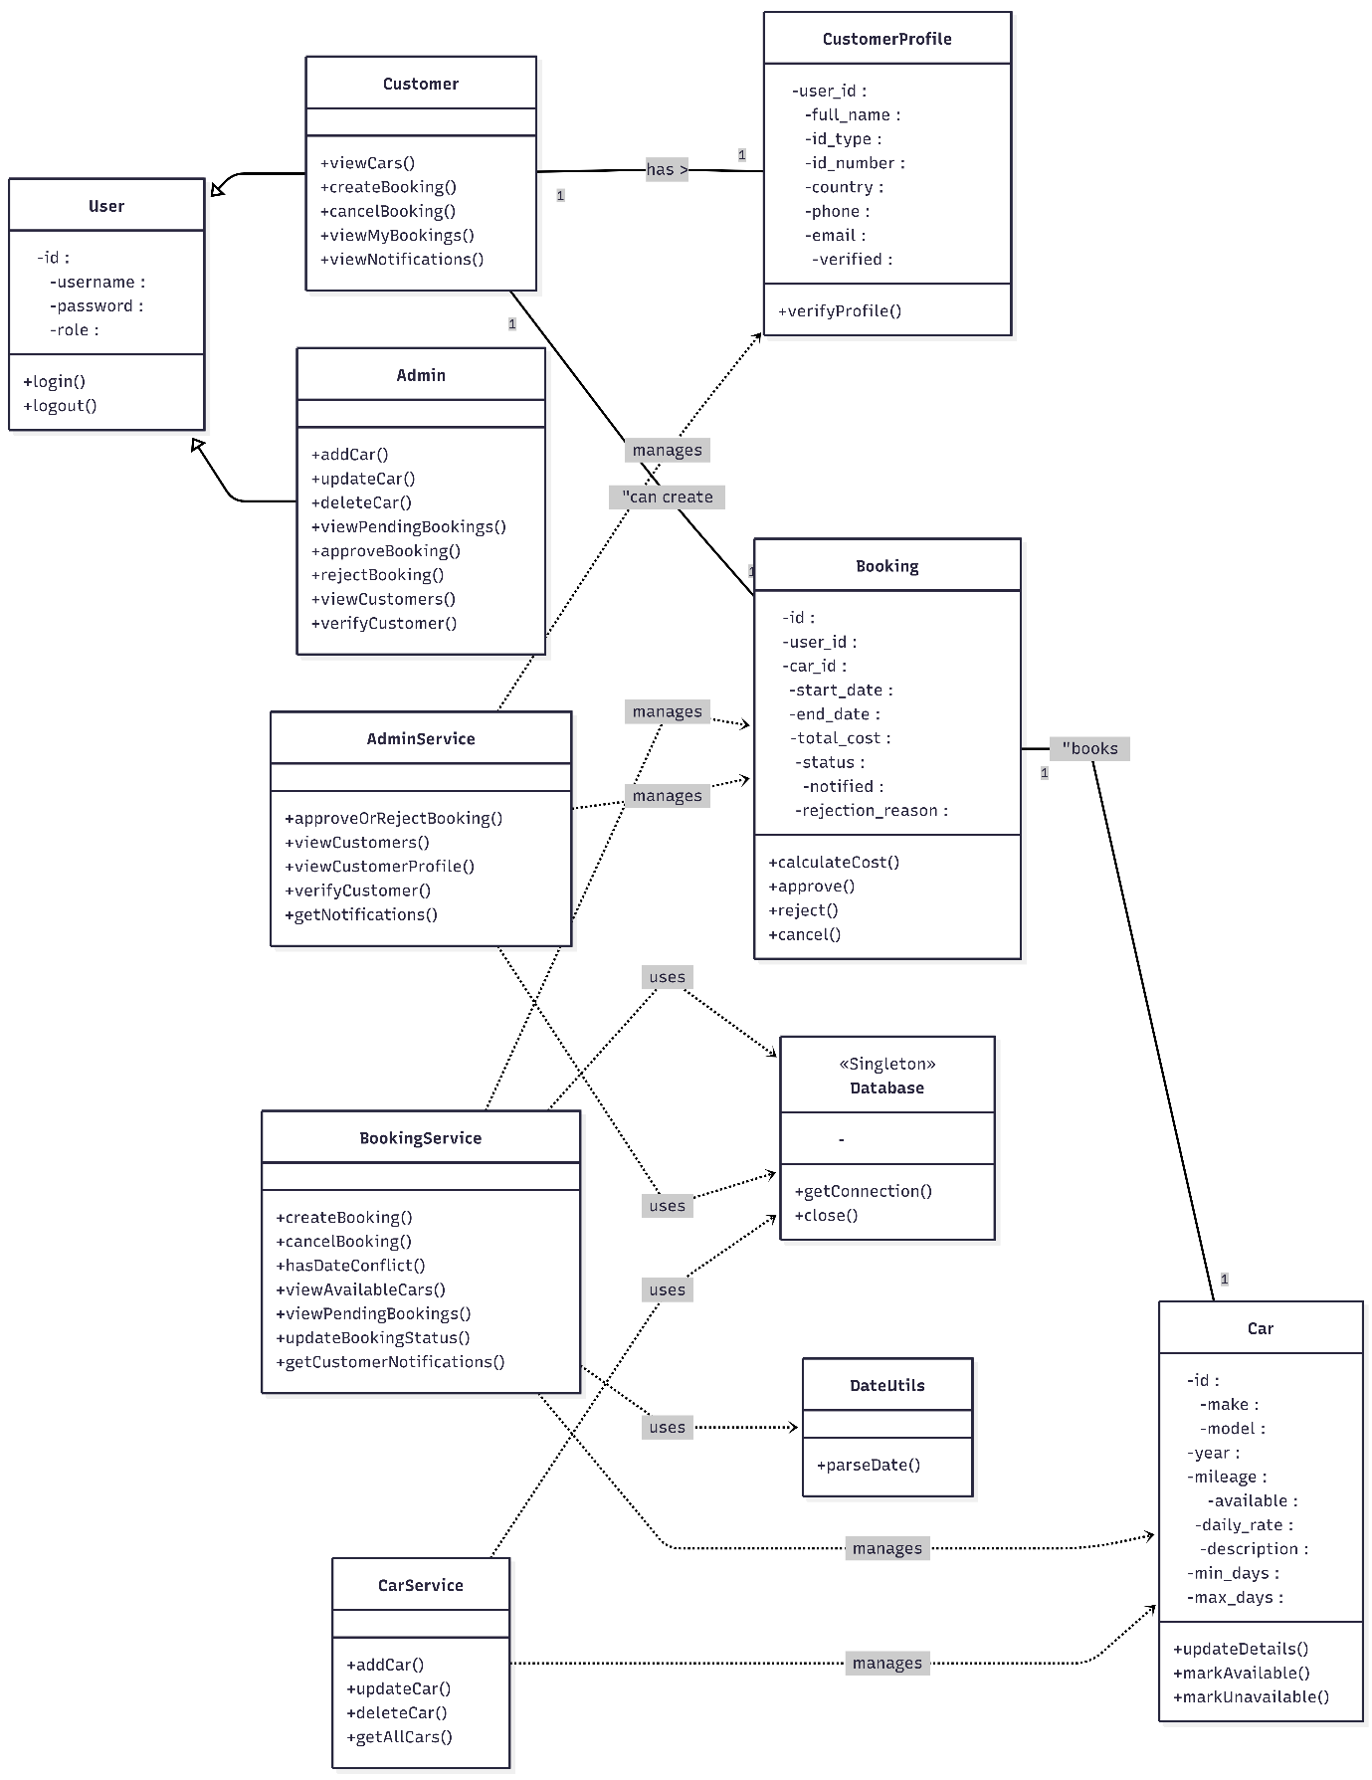
Figure 2: Class Diagram of the Car Rental System

Key Classes:
- User (base class)
- Customer and Admin (inherit from User)
- Car
- Booking
- CustomerProfile
- Service classes (BookingService, AdminService, CarService)
- Utility classes (Database, DateUtils)

Relationships:
- Inheritance: Admin and Customer extend User
- One-to-One: Customer → CustomerProfile
- One-to-Many: Customer → Booking
- Many-to-One: Booking → Car
- Dependency: Service classes depend on the Database Singleton
This structure ensures:
- Strong encapsulation
- Clear ownership of data
- Loose coupling between layers
The class diagram represents the static structure of the system, showing classes, attributes, methods, and relationships such as inheritance, association, and dependency. It highlights object-oriented principles such as encapsulation and inheritance.

4.3 Sequence Diagram
The Sequence Diagram demonstrates the booking workflow, including administrative approval.
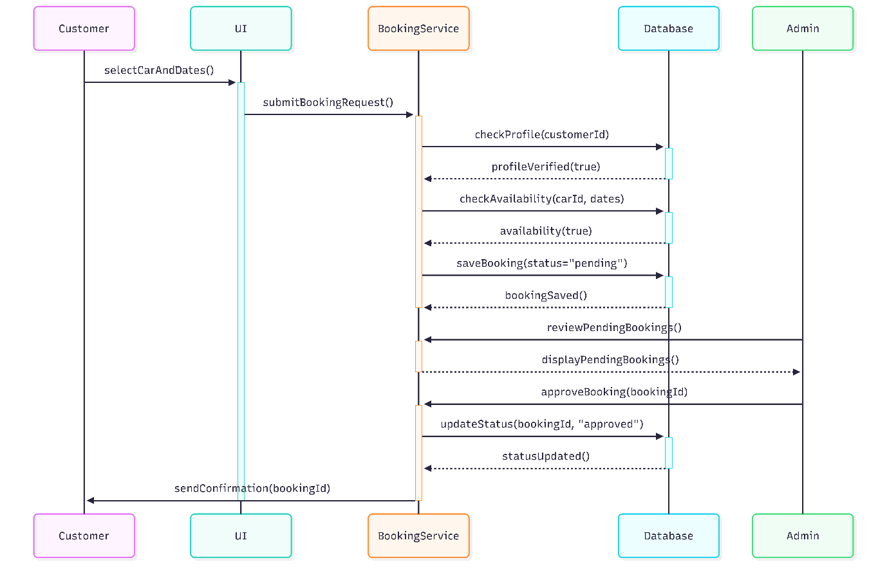
Figure 3: Booking and Approval Sequence Diagram

Workflow Overview:
- Customer selects a car and rental dates
- UI forwards the request to BookingService
- Availability and date conflicts are checked
- Booking is saved with status pending
- Admin reviews and approves the booking
- Booking status is updated in the database
- Customer receives a notification
The sequence diagram accurately reflects real system behavior, including validation, persistence, and notification handling.
This sequence diagram demonstrates the runtime interaction between system components during the booking process, including customer booking creation, validation, admin approval, and notification.

5. Summary
The system architecture demonstrates effective application of advanced software engineering principles.
Through the use of layered design, UML modeling, and design patterns, the Car Rental System achieves:
- Modularity
- Maintainability
- Scalability
- Clear role separation
- Robust business logic enforcement
This design supports future enhancements such as a graphical interface, mobile integration, or cloud deployment without requiring significant refactoring.

